# Taller 2 API REST

## Punto 1 | Perros

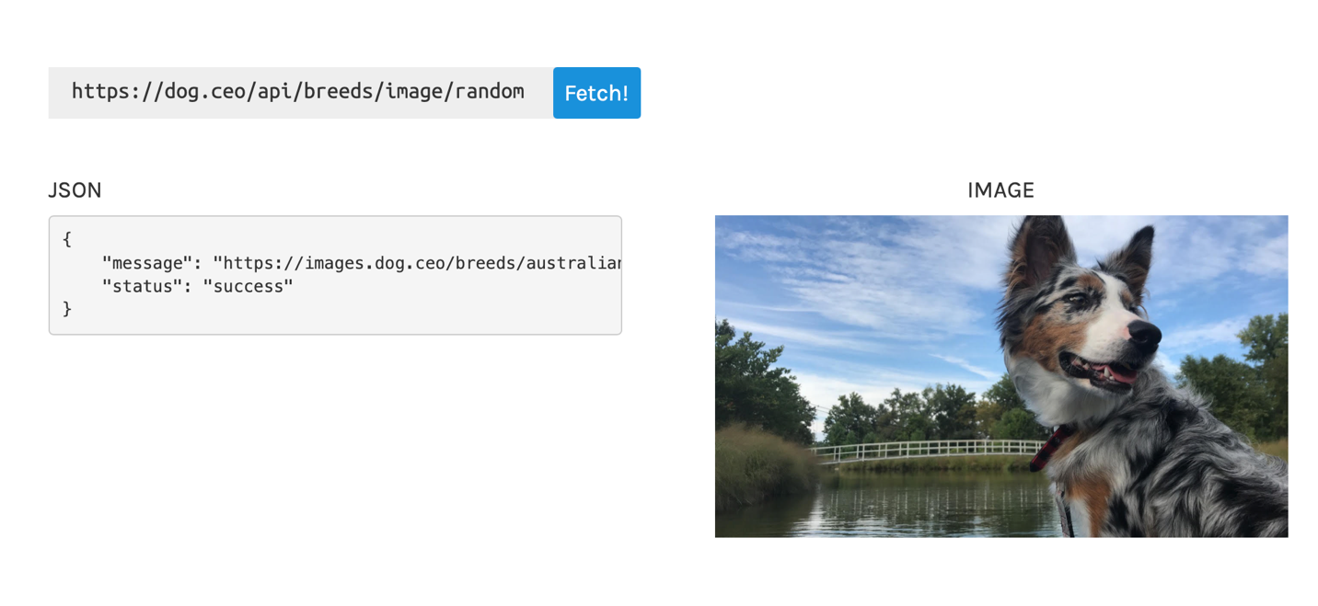

https://dog.ceo/api/breed/mountain/bernese/images/random/3

{

"message": [

"https://images.dog.ceo/breeds/mountain-bernese/n02107683_1429.jpg",

"https://images.dog.ceo/breeds/mountain-bernese/n02107683_3034.jpg",

"https://images.dog.ceo/breeds/mountain-bernese/n02107683_522.jpg"

],

"status": "success"

}

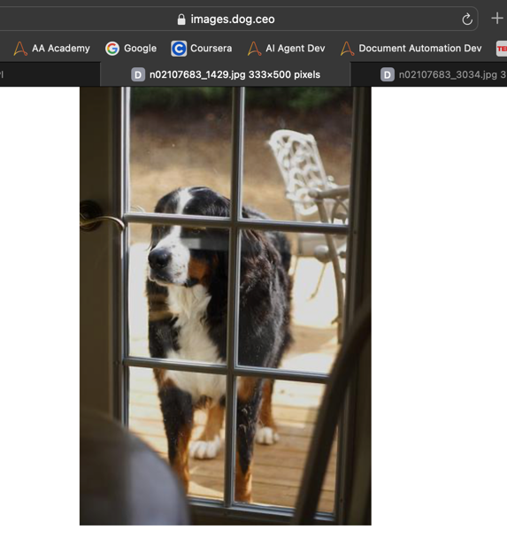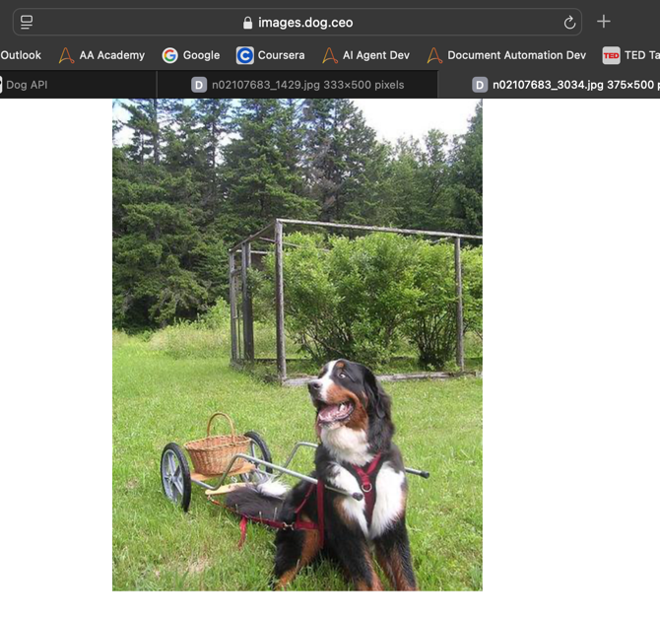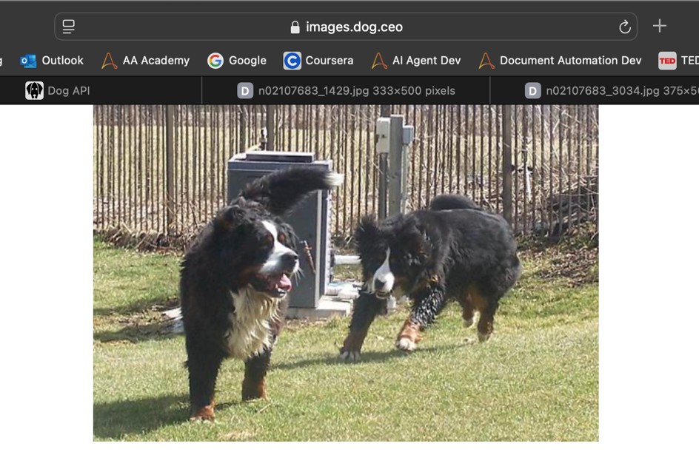

## Punto 2 | Pokémon

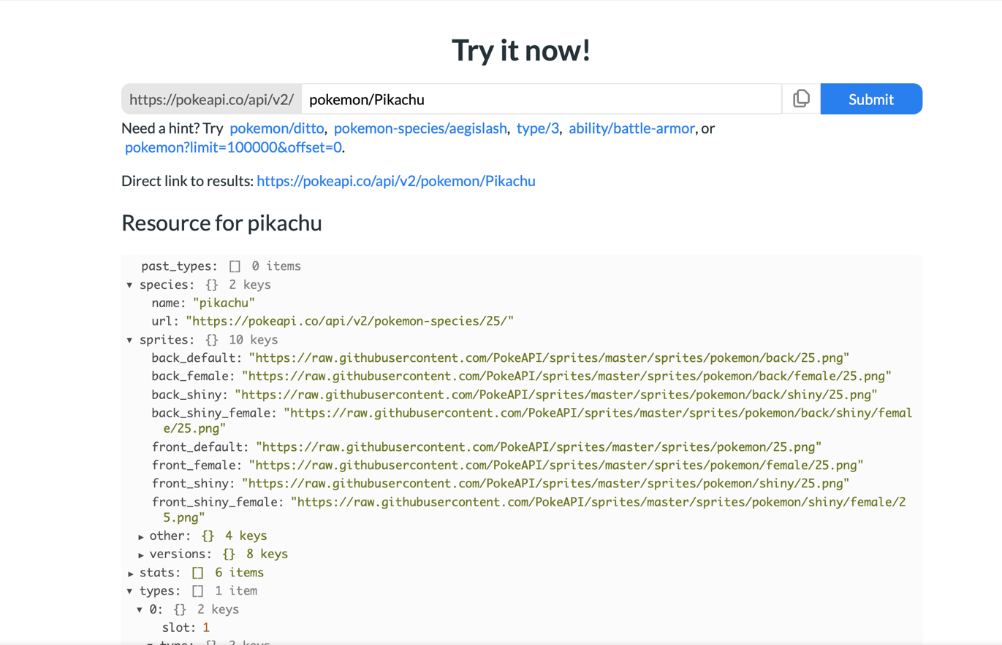

Sprites Pikachu

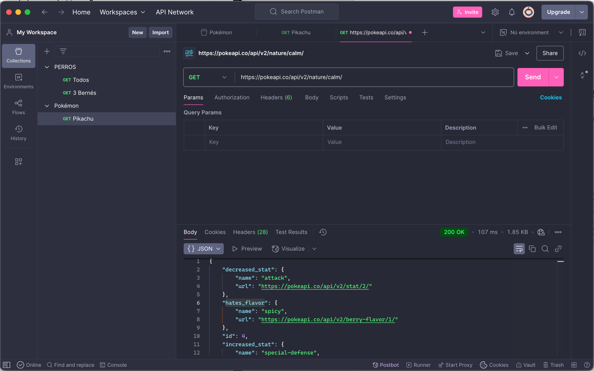

"hates_flavor": {

"name": "spicy",

"url": "https://pokeapi.co/api/v2/berry-flavor/1/"

},

## Punto 3 | Rick and Morty

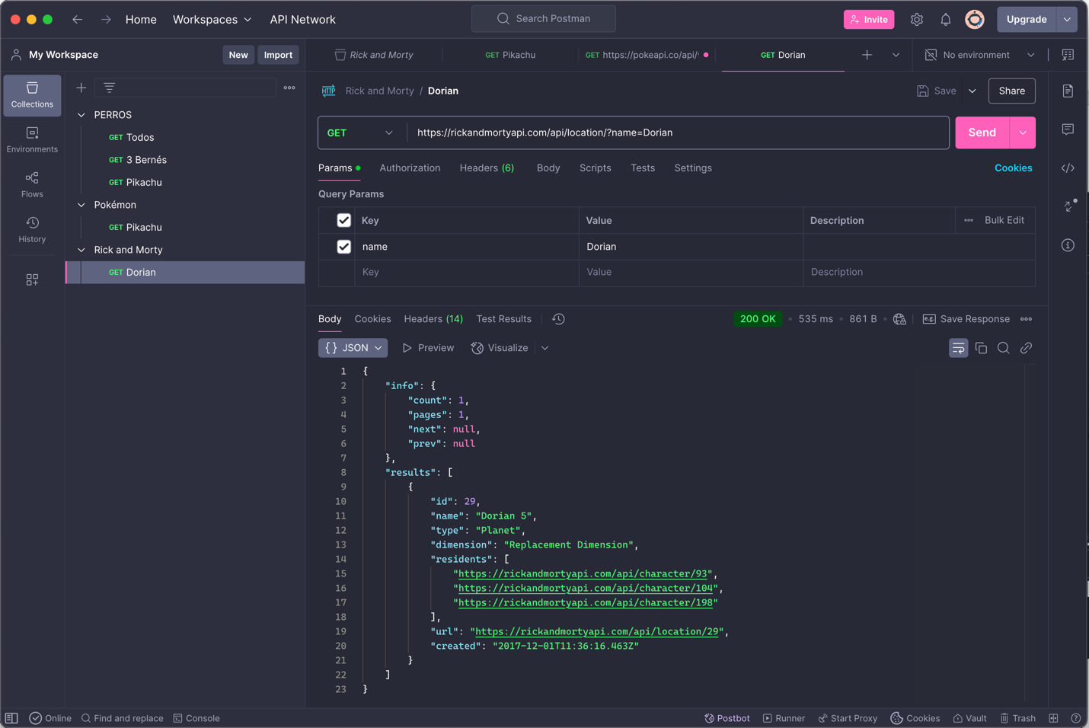

{

"info": {

"count": 1,

"pages": 1,

"next": null,

"prev": null

},

"results": [

{

"id": 29,

"name": "Dorian 5",

"type": "Planet",

"dimension": "Replacement Dimension",

"residents": [

"https://rickandmortyapi.com/api/character/93",

"https://rickandmortyapi.com/api/character/104",

"https://rickandmortyapi.com/api/character/198"

],

"url": "https://rickandmortyapi.com/api/location/29",

"created": "2017-12-01T11:36:16.463Z"

}

]

}

## Punto 5 | Nuestro propio API, ¿Cómo hace el animal?

### ¿Cómo hace el Perro?

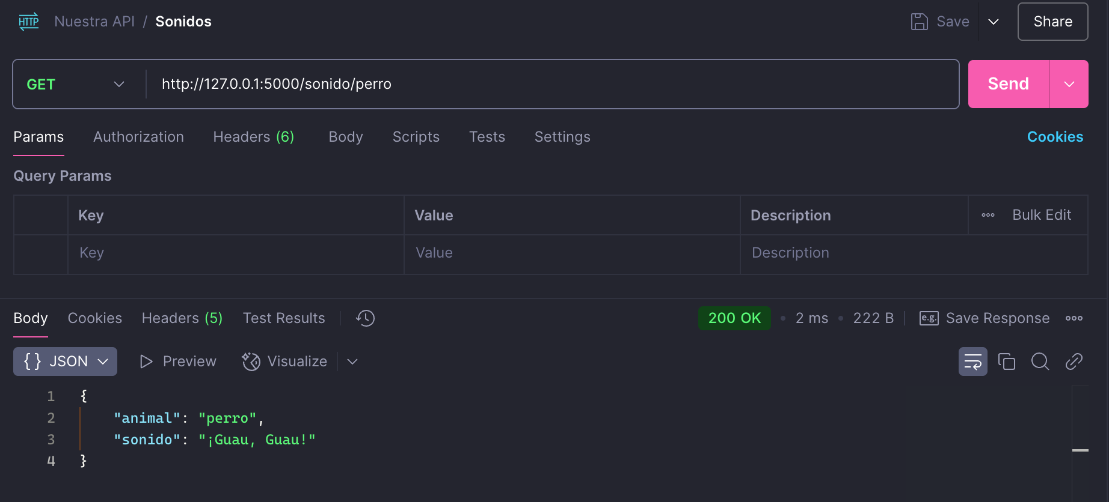

### ¿Cómo hace el Hurón?

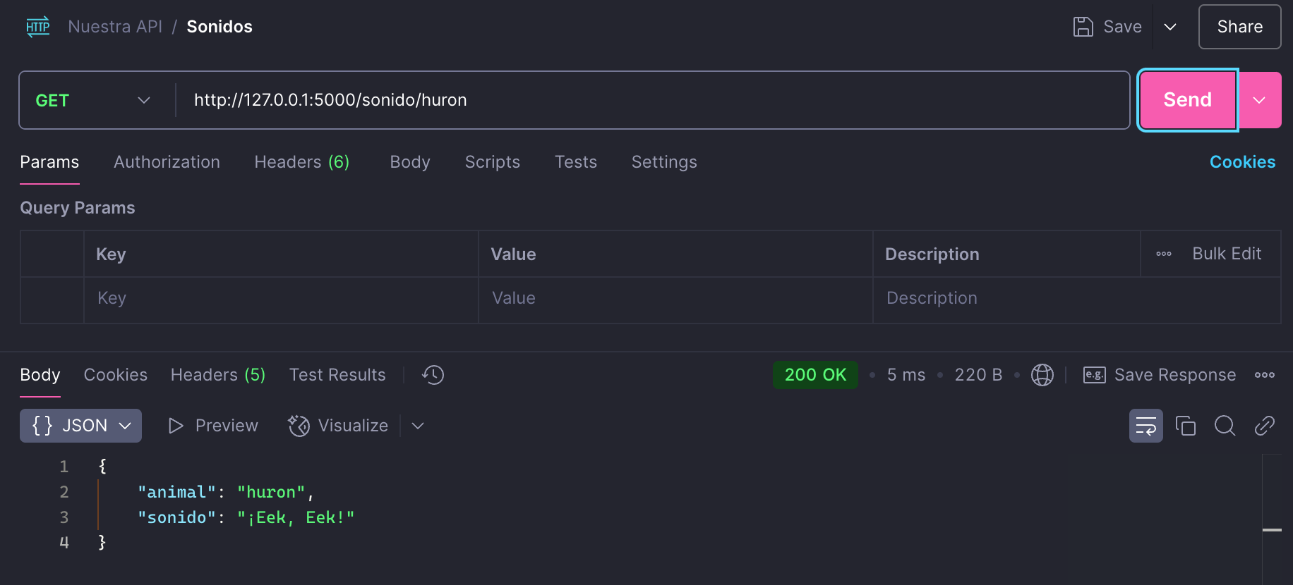

### Visual en Web

